Numbers
1. Count forwards(1-30) and backwards(30-1)
1 | 2 | 3 | 4 | 5 | 6 | 7 | 8 | 9 | 10
11 | 12 | 13 | 14 | 15 | 16 | 17 | 18 | 19 | 20
21 | 22 | 23 | 24 | 25 | 26 | 27 | 28 | 29 | 30
31 | 32 | 33 | 34 | 35 | 36 | 37 | 38 | 39 | 40
41 | 42 | 43 | 44 | 45 | 46 | 47 | 48 | 49 | 50
Numbers
1. Count forwards(1-30) and backwards(30-1)
1 | 2 | 3 | 4 | 5 | 6 | 7 | 8 | 9 | 10
11 | 12 | 13 | 14 | 15 | 16 | 17 | 18 | 19 | 20
21 | 22 | 23 | 24 | 25 | 26 | 27 | 28 | 29 | 30
31 | 32 | 33 | 34 | 35 | 36 | 37 | 38 | 39 | 40
41 | 42 | 43 | 44 | 45 | 46 | 47 | 48 | 49 | 50
Numbers
1. Count forwards(1-30) and backwards(30-1)
1 | 2 | 3 | 4 | 5 | 6 | 7 | 8 | 9 | 10
11 | 12 | 13 | 14 | 15 | 16 | 17 | 18 | 19 | 20
21 | 22 | 23 | 24 | 25 | 26 | 27 | 28 | 29 | 30
31 | 32 | 33 | 34 | 35 | 36 | 37 | 38 | 39 | 40
41 | 42 | 43 | 44 | 45 | 46 | 47 | 48 | 49 | 50
Number symbols (group 1)
1. Colour the following number symbols.
1 | 2 | 3 | 4 | 5 | 6 | 7 | 8 | 9 | 10
11 | 12 | 13 | 14 | 15 | 16 | 17 | 18 | 19 | 20
21 | 22 | 23 | 24 | 25 | 26 | 27 | 28 | 29 | 30

Number symbols (group 1)
1. Colour the following number symbols.
1 | 2 | 3 | 4 | 5 | 6 | 7 | 8 | 9 | 10
11 | 12 | 13 | 14 | 15 | 16 | 17 | 18 | 19 | 20
21 | 22 | 23 | 24 | 25 | 26 | 27 | 28 | 29 | 30
Number symbols (group 2)
1. Trace the following number symbols.
1 | 2 | 3 | 4 | 5 | 6 | 7 | 8 | 9 | 10
11 | 12 | 13 | 14 | 15 | 16 | 17 | 18 | 19 | 20
21 | 22 | 23 | 24 | 25 | 26 | 27 | 28 | 29 | 30

Number symbols (group 2)
1. Trace the following number symbols.
1 | 2 | 3 | 4 | 5 | 6 | 7 | 8 | 9 | 10
11 | 12 | 13 | 14 | 15 | 16 | 17 | 18 | 19 | 20
21 | 22 | 23 | 24 | 25 | 26 | 27 | 28 | 29 | 30

Number symbols (group 3)
1. Fill in the missing numbers.
1 |  | 3 |  | 5 |  | 7 |  | 9
11 |  | 13 |  | 15 |  | 17 |  | 19
21 |  | 23 |  | 25 |  | 27 |  | 29 | 30
Number symbols (group 3)
1. Fill in the missing numbers.
1 |  | 3 |  | 5 |  | 7 |  | 9
11 |  | 13 |  | 15 |  | 17 |  | 19
21 |  | 23 |  | 25 |  | 27 |  | 29 | 30

Number symbols and names 1 – 10 (group 1)
1. Colour the number and the number name.
1 one
2 two
3 three
4 four
5 five
6 six
7 seven
8 eight
9 nine
10 ten

Number symbols and names 1 – 10 (group 2)
1. Trace the number and the number name. In the empty line try and write it yourself.
1 one
2 two
3 three
4 four
5 five
6 six
7 seven
8 eight
9 nine
10 ten
Number symbols and names 1 – 10 (group 3)
1. Copy the number and the number name.
1 one --- ----
2 two --- ----
3 three --- ----
4 four --- ----
5 five --- ----
6 six --- ----
7 seven --- ----
8 eight --- ----
9 nine --- ----
10 ten --- ----

Data handling
1. Colour the stars yellow, the hearts red and the triangles blue.

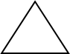

2. Count the above shapes and tells how many of each did you count

---------
----------

----------

Comparing whole numbers 1-10 (group 3)
1. Count each group of objects, write the number and colour the group that has less objects.
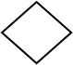

Comparing whole numbers 1-10 (group 2)
1. Count each group of objects, trace the outline and colour the group that has less objects.

Comparing whole numbers 1-10 (group 1)
1. Count each group of objects and colour the group that has less objects.

Comparing whole numbers 1-10 (group 1)
1. Count the objects in each, say which group has more or less objects.
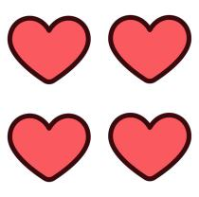 |  | 
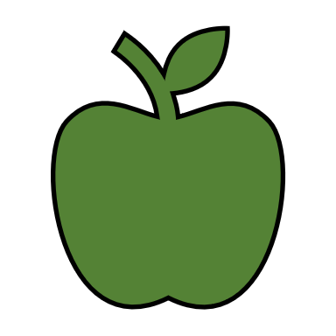




Comparing whole numbers 1-10 (group 2)
1. Count the objects in each group, circle the group with more objects with red and the group with less objects with blue.


Comparing whole numbers 1-10 (group 3)
1. Count the object in each group, circle the group with more objects with red and the group with less objects with blue.

Position (group 1)
on top of, in front of, behind, up, down, next to
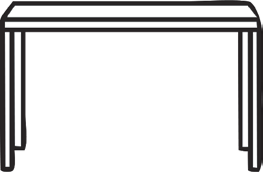

1. Colour and say/point the position of the ball in relation to the table.

Position (group 2)
1. Colour each object, trace the words next to it and lastly match the picture to the correct position.
next to

behind
up
on top of
in front of
down

Position (group 3)
1. Colour and write the best description for each position below.
on top of, in front of, behind, up, down, next to
3D Shapes (group 1)
- Colour the boxes yellow
- Colour the balls purple

3D Shapes (group 2)
1. Trace and colour all balls purple and the boxes yellow.

box

box

ball

box

ball

3D Shapes (group 3)
1. Draw and name the following 3D shape:
- 2 big balls
- 2 small balls
- 2 big boxes
- 2 small balls

